
GASABO DISTRICT

DISTRICT COMPREHENSIVE ASSESSMENT,
RTQF LEVEL IV SOFTWARE DEVELOPMENT,
SFDDW401 WEBSITE DEVELOPMENT (2022-2023).
TRADE: Software Development
MODULE: Website development
DATE OF EXAM: ………………………… Duration: 3 hours (… …h…- …….h…… or .....hrs.)
ACADEMIC YEAR: 2022-2023

Instructions:
- This paper is composed by Three sections
- All questions are Compulsory in section A (55marks)
- Attend any three questions in section B (30marks)
- Question in section C is Compulsory (15marks)

SECTION A: ATTEMPT ALL QUESTIONS /55 MARKS
- Define the following words: (6marks)
  - Web page
  - Website
  - Hyperlink
  - html “Form”
  - POST Method
  - GET Method
- List six (6) HTML Headings used to design a web page. (3marks)
- What is text editor? Which editors that can be used for HTML development?
Give three (3) examples. (1.5marks)
- With examples, explain the difference between <UL> and <OL> in website development? (4marks)
- Mention any four (4) advantages of CSS within website development. (4marks)
- How to align <table> right/Left in HTML? (3marks)
- Give the difference between attribute, element and tag. (1.5marks)
- How many ways a CSS can be integrated in a webpage? (3marks)
- Explain at least Four (4) types of CSS selectors (4marks)
- After defining a browser, state any two (2) examples of browsers. (4marks)
- Give any three (3) images file formats (3marks)
1…………………………2…………………………3………………………
- Html tags are divided into two (2) types. Explain those types with examples. (4marks)
- Write the output of the following code? (5marks)
<html>
<head>
<title></title>
</head>
<body>
<form>
Firstname:<br>
<input type=”text” name=”Firstname” value=”Mickey”><br>
Lastname:<br>
<input type=”text” name=”Lastname” value=”Mouse”><br><br>
<input type=”submit” value=”Submit”>
<input type=”reset” value=”cancel”>
</form>
</body>
</html>
- Describe the difference between static and dynamic website (3marks).

- Choose the correct answer:
Which tag creates a check box for a form in HTML? (3marks)
a. <checkbox>
b. <input type=” checkbox”>
c. <input=checkbox>
d. <input checkbox>
- The figure below shows CSS rules:
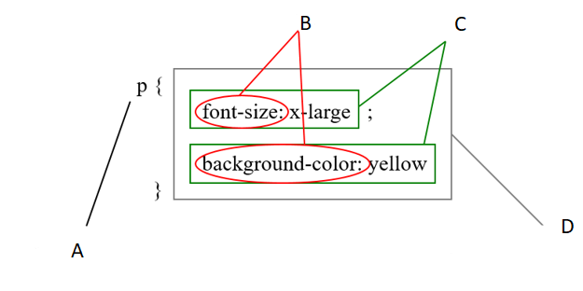
Name the letters A, B, C, D (2marks)

- A) Give two main parts of an html attribute (2marks)
1. ………………………………… 2. ……………………………………………………….
B) Provide at least 1 example for each by using the following attributes. (3marks)
- alt: ….………………………………………………………………………………..........
- title: …..……………………………………………………………………………..........
- src: ………………………………………………………………………………………….

SECTION B: ATTEMPT ONLY 3 QUESTIONS /30 MARKS

- What do the following tags mean in a web design? (10marks)
  - <HTML> </HTML>
  - <TITLE></TITLE>
  - <BODY></BODY>
  - <I></I>
  - <SUB> </SUB>

- a. Write HTML code to produce the following Output: (5marks)
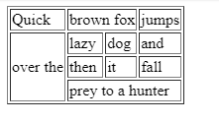
b. Write html codes to draw the following table (5marks)
Lettre | Code | Signification
à | &grave; | a accent grave
É | &Eucute; | e majuscule
© | &copy; | copyright

- Analyze the following HTML Codes, and give Output. (10marks)

<html>
<head>
<title>Website development</title>
</head>
<body>
<table border="2" width="600" >
<tr>
<td colspan="6" align="center" bgcolor="yellow">
STUDENTS MARK SHEET
</td>
</tr>
<tr bgcolor="green" >
<td width="200">Name</td>
<td>Maths</td>
<td>Science</td>
<td>English</td>
<td>Physics</td>
<td>General Knowledge</td>
</tr>
<tr>
<td>David</td>
<td>85</td>
<td>87</td>
<td>88</td>
<td>92</td>
<td>88</td>
</tr>
<tr>
<td>Richard</td>
<td>91</td>
<td>81</td>
<td>78</td>
<td>71</td>
<td>74</td>
</tr>
<tr>
<td>John</td>
<td>81</td>
<td>86</td>
<td>88</td>
<td>84</td>
<td>92</td>
</tr>
<tr>
<td>Tony</td>
<td>84</td>
<td>86</td>
<td>87</td>
<td>82</td>
<td>81</td>
</tr>
<tr>
<td>Scott</td>
<td>71</td>
<td>79</td>
<td>82</td>
<td>88</td>
<td>89</td>
</tr>
</table>
</body>
</html>
- Match in the following table each term in middle column and its corresponding meaning in the right column and then write the answer in the left column(10marks)
Answer | Tag | Description
- ………. | 1. <!DOCTYPE> | a)Define a cell in a table
- ………. | 2. <HTML> | b)Groups the header
- ………. | 3. <TD> | c) This tag encloses the complete HTML documents and mainly comprises of document header which is represented by <head>…</head> and document body which is represented by <body>…</body> tags.
- ………. | 4.<THEAD> | d) Defines a header cell in a table
- ………. | 5.<TH> | e) This tag defines the document type and HTML version.

- Produce html code that provides the below information (10marks).
- Bold text: ………………………………………………………………………………
- Italic: ………………………………………………………………………………….….
- Underlined text: ….…………………………………………………………………...
- H₂O: ...…………………………………………………………………………………...
- Today is 15th: ………………………………………………………………………….

SECTION C. ATTEMPT One(1) QUESTIONS /15 MARKS
- Design the following table with html codes.(4marks)
LEVEL FOUR Software Development
No |  |  | %
Name |  |  | %
Email |  |  | %

- Write html code to create a form that will ask the username , email, and
password and add an appropriate attribute to the username field to prevent submitting it empty and the button to submit the field’s values and add a reset button that can clear the form once you typed wrong information. (15marks)

- Here there is a website design rules and their objectives. Using HTML list,
Write HTML codes to produce the following Output. (15marks)

